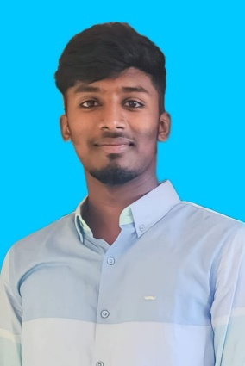

**S.RIYAS KHAN**

Riyaskhan1602@gmail.com

**Contact:7305950554**

**CAREER OBJECTIVES**

To work in the challenging and creative environment and effectively contribute towards the goals of the organization and also I would like to contribute to the development of company .

**ACADEMIC PERFORMANCE**

|  |  |  |  |  |
| --- | --- | --- | --- | --- |
| **Course** | **Institute** | **Board/**  **University** | **Year of**  **passing** | **% of**  Marks |
| B.SC  (CS) | Government arts College,  Coimbatore-45  (Autonomous) | Bharathiar University | 2024 | 78.24%  (4th sem) |
| II HSC | St.Michael’s Higher Secondary school. | State board | 2021 | 82.5% |
| I HSC | St.Michael’s Higher Secondary school. | State board | 2020 | 65.16% |
| SSLC | St.Michael’s Higher Secondary school. | State board | 2019 | 74.8% |

**ACHIEVEMENTS AND CO-CURRICULAR ACTIVITIES**

* + Member of National Social Service.
  + Participated in various events in college level.

**SKILL SET**

* + MS Word ,MS Excel (Basic Computer Knowledge)
  + Language : Basic Knowledge of C, C++, Python, HTML, CSS.

**AREAS OF INTEREST**

* + Web Designing
  + Database Management

**PERSONAL DETAILS**

Father’s Name : J.Sheik abdulla

DOB : 16/02/2004

Gender : Male

Languages known : Tamil,English

Religion : Muslim

Nationality : Indian

Address : 50/A Kottaipudur,Tyre company ,south ukkadam ,

Coimbatore-641001

**DECLARATION**

I Hereby declare that the above mention information is true to the best of my knowledge.

**(S.Riyas khan)**